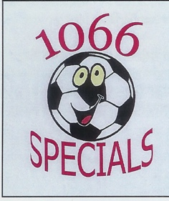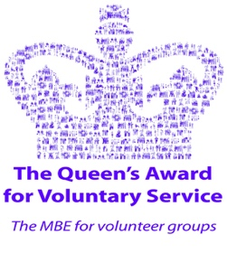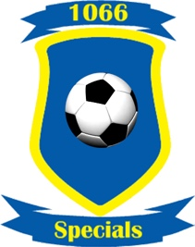

1066 Specials FC – Code of Conduct

Players Name: …………………………………………………………………………

In registering for 1066 Specials Football Club, the above-named player agrees to the following code of conduct as set out below.

The Player agrees to:

- Attend training sessions regularly and punctually at the time and dates set by the coaching staff.
- I will try never to be rude, use bad or offensive language or get angry towards others.
- Come appropriately dressed to both training and matches with suitable footwear, shin pads and a drink.
- Demonstrate good behaviour both on and off the pitch, setting a good example to others.
- Treat opponents, officials, team mates and spectators in line with FA respect programme.
- Not to drink alcohol at any time when they are representing the club.
- Pay weekly subs which are set out by the committee.
- Listen and do what the referee/coaches asks me to do.
- Shake hands with the other teams and referee at the end of the game (Covid19 restrictions currently apply).
- Listen to my coach/team manager and respect what they say.
- Talk to someone I can trust, for example my parents/carers, coach or the club welfare officer if I am unhappy about anything at my club.

I understand that if I do not follow the code of conduct, I may be asked to:

- Stop training or playing and take time out on the side lines.
- Leave the pitch to discuss the situation with a 1066 Coach.
- Not to attend the next training session or tournament game.
- With a warning I may be asked to leave the Club.

The Club agrees to:

- Supply playing kit for use during competitive/friendly matches.
- Provide regular training opportunities to develop players skills and fitness.
- Select players without prejudice and in accordance to the requirements of the team fixture.
- Advise players on their performances and future development.
- Provide playing opportunities where appropriate in tournaments and training sessions.
- Be available to players to discuss any queries relating to the Football Club.

